BALTIC ORIENTEERING CHAMPIONSHIPS 2013
(WRE May 19 )
&
BALTIC MASTERS OPEN CHAMPIONSHIPS
&
BALTIC OPEN COMPETITION

May 17-19, 2013, RUUSMÄE, Estonia

Bulletin 1-2

Organizers: Estonian Orienteering Federation, OK Võru
Event director: Sixten Sild
Secretary: Erik Saarts
Course setter: Markus Puusepp

Event control:
IOF Event Adviser: Leho Haldna
National controller: Paul Poopuu

Event venue and event centre:
Event venue is Haanja parish (http://www.haanja.ee) in Võru county, south-east Estonia http://www.visitvoru.ee/en/.
Event centre is Rogosi manor in Ruusmäe village (www.rogosi.ee).

Competition centre: Kuura, 5 km south-east from Ruusmäe, follow signs from Ruusmäe or from the Riga-Pskov road (from Käbli village).

Event venue maps:
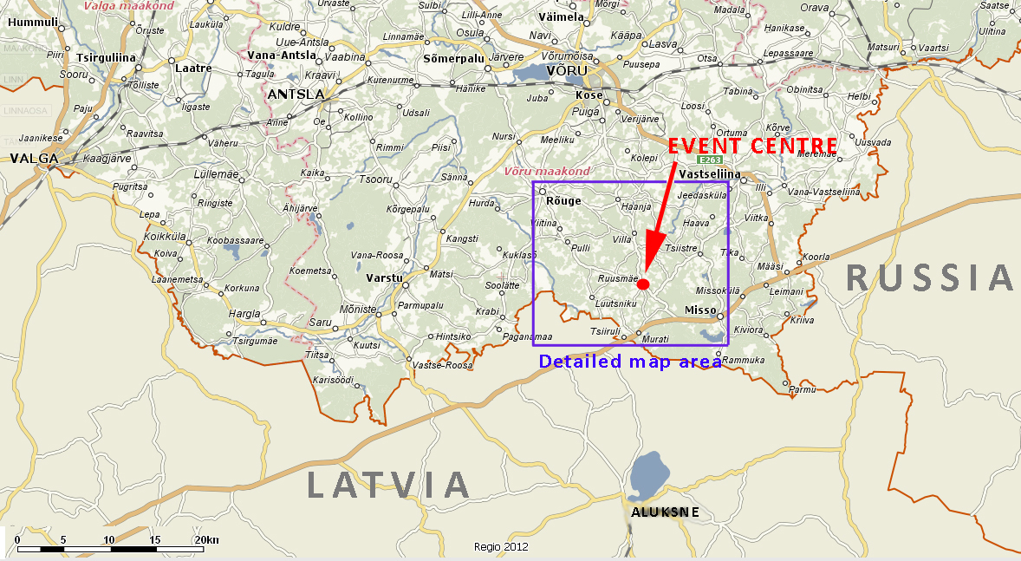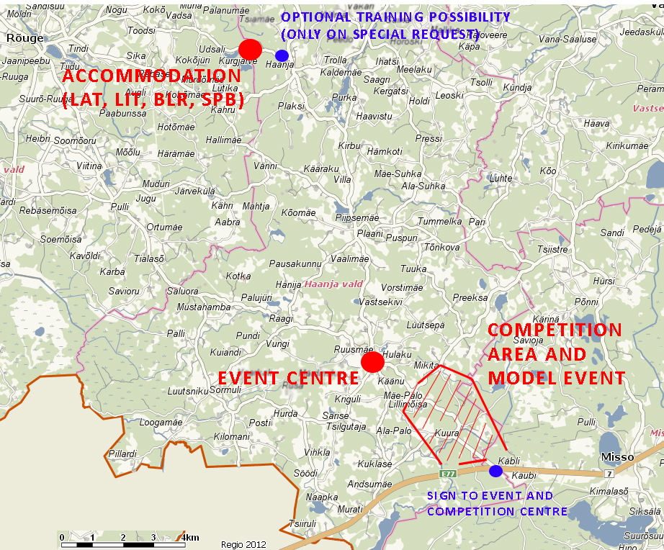

Programme: Friday, May 17
From 16:00 Arrival of the Teams to model event or accommodations
17:00-19:00 Model Event
19:00-20:30 Dinner at accommodations

Saturday, May 18
7:00-9:00 Breakfast at accommodations
9:30 First start of long distance competition (national teams, WRE)
12:00 First start of long distance competition on Baltic Masters Open Championships and Baltic Open Competition
14:00-15:30 Lunch at accommodations
18:00 First start of open Rogosi sprint competition in Ruusmäe (at event centre)
18:00-20:00 Sightseeing in Rogosi manor, Ruusmäe
19:00-20:00 Dinner (Pasta party) for national teams at event centre
20:00 Prize-giving of the first day of Baltic championships & Rogosi sprint at event centre
20:30-22:00 Come-together-party with music, dance perfomance, spontaneous show-ups etc. at event centre
21:30-22:00 Team leaders’ meeting at event centre
22:00 Departure of the teams from Ruusmäe to accommodations

Sunday, May 19
7:00-9:00 Breakfast at accommodations
10:00 First start of the relay competition for national teams
10:30 First start of the middle distance competition of Baltic Masters Open Championships and Baltic Open Competition
13:30 Prize-giving and closing ceremony at competition centre
14:00-15:00 Lunch at accommodations/at competition centre ?

Participants and competition classes
Baltic Championships
Participants are the national teams of Estonia, Latvia, Lithuania, Belarus and Saint Petersburg. Each of the named federations may enter a team of up to 56 competitors - up to 28 women and 28 men - and 5 team officials.
Teams of participating federations consist as follows:
MW14E : 4+4
MW16E : 5+5
MW18E: 5+5

MW20E: 4+4

MW21E: 10+10

Other runners (non team-members) may participate in WRE, but they are competing outside of Baltic Championships.

Long distance classes:
W14E, W16E, W18E, W20E, W21E
M14E, M16E, M18E, M20E, M21E

Relay classes (3 legs per team):
W16E, W20E, W21E
M16E, M20E, M21E

Number of participants in Baltic Masters Open Championships and Baltic Open Competition is not limited (participants from all countries are welcome).
Competition classes:
Baltic Masters Open Championships:
MW35, MW40, MW45, MW50, MW55, MW60, MW65, MW70, MW75

Baltic Open Competition:
MW10, MW12, MW14, MW16, MW18, MW20, MW21, Open (without pre-registration)

Preliminary course lengths (km):
Baltic Championships
LONG |  |  | RELAY
Class | km |  | Class | km | Class | km
M14E | 4 |  | M21E | 3x6,5 | W21E | 3x4,5
M16E | 6,5 |  | M20E | 3x5,0 | W20E | 3x4,0
M18E | 8 |  | M16E | 3x3,5 | W16E | 3x3,0
M20E | 10
M21E | 15
W14E | 3,5
W16E | 4,5
W18E | 6
W20E | 7
W21E | 9

Baltic Masters Open Championships and Baltic Open Competition
 | km |  |  |  | km
Class | LONG | MIDDLE |  | Class | LONG | MIDDLE
M35 | 9 | 5,5 |  | M10 | 2 | 1,5
M40 | 8 | 5 |  | M12 | 2,5 | 2
M45 | 7,5 | 4,5 |  | M14 | 3 | 2,3
M50 | 6,5 | 4 |  | M16 | 4,5 | 3
M55 | 6 | 3,5 |  | M18 | 6 | 4
M60 | 5,5 | 3,5 |  | M20 | 7,5 | 5
M65 | 5 | 3 |  | M21 | 10 | 6
M70 | 4,5 | 2,5 |  | W10 | 2 | 1,5
M75 | 4 | 2,5 |  | W12 | 2,3 | 2
W35 | 6 | 3,5 |  | W14 | 2,5 | 2
W40 | 5,5 | 3 |  | W16 | 3,5 | 2,5
W45 | 5 | 3 |  | W18 | 4,5 | 3
W50 | 4,5 | 2,5 |  | W20 | 6 | 3,5
W55 | 4 | 2,5 |  | W21 | 7 | 4,5
W60 | 4 | 2,3 |  | OPEN | 5 | 3
W65 | 3,5 | 2,3
W70 | 3 | 2
W75 | 2,5 | 2

Map:
Previous map from 1973 covers part of the terrain of BOC 2013:
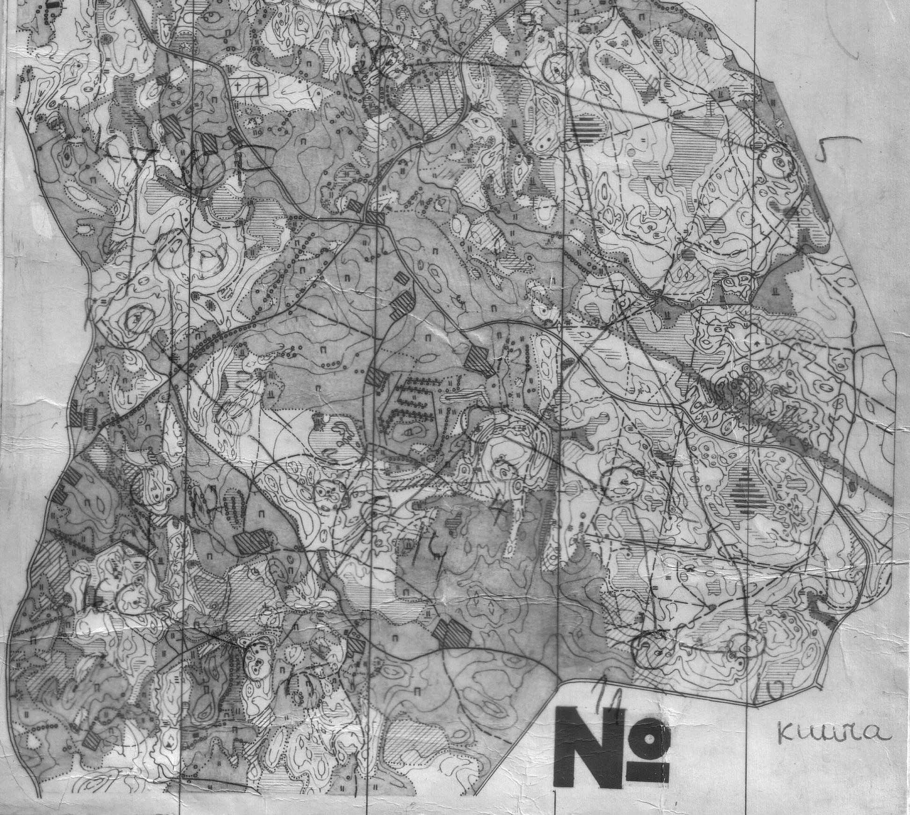

New map: Kuura, No 2013006 http://www.orienteerumine.ee/kaart/kaartshow.php?Kood=2013006

Mapper: Kalle Kalm, drawn in autumn 2012

Terrain: Southern slope of Haanja upland, absolute heights in the terrain vary between 215 a.s.l. in the northern part and 175 m a.s.l. in the southern part of the map. Maximum height difference on one slope is 20 m. Medium sized and small hills and depressions are interlaced by marshes of different shapes and sizes. The terrain is very variable in regard to contour features and vegetation. Mixed forest with spruces and pines dominating. Runnability is very varying, but mostly average. Network of roads, paths, and narrow rides is quite poor. Paths and narrow rides are often overgrown. Forested areas make up to 80% of the terrain.

Map samples (NB! on the samples h=2,5m):
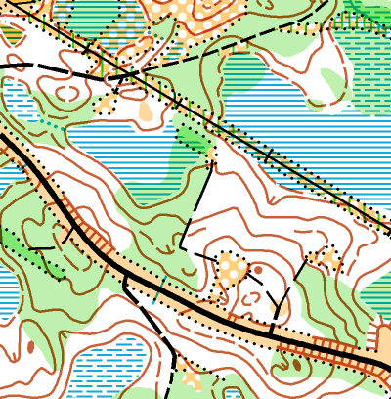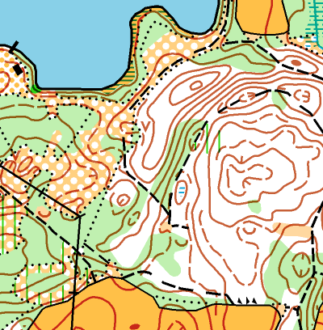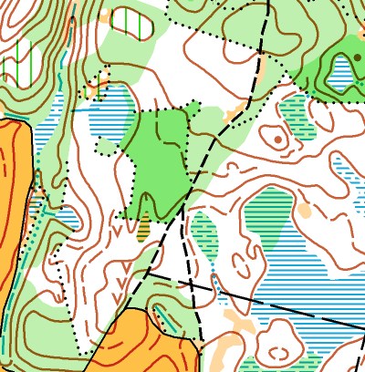

Map scales:
Long distance (Day 1):
1:15 000 MW16E; MW18E; MW20E; MW21E;
1:10 000 MW14E; all other classes

Relay, middle distance (Day 2):
1:10 000 for all classes;
Contour interval 5 metres

Competition maps are in plastic bags, control descriptions are printed on the maps, additional loose descriptions are available in pre-start (except the relay).

Embargoed area: http://www.orienteerumine.ee/kaart/kaartshow.php?Kood=2013006

Training possibilities:
Baltic championships (national teams, WRE runners):
Model event on Friday, 17.05 from 17:00-19:00 on a minor part of the competition map. Model event maps will be available at the event centre or as agreed with organizers prior to arrival.

Baltic Masters Open Championships and Baltic Open Competition:
Model event maps (part of competiton map) are available on request. Map fee 1 EUR. Model event map request has to be indicated in the entry. Maps will be handed out at model event start area (follow the marked route from Ruusmäe)

Additional training possibilities:
Organisers offer additional training possibilities on following relevant map on request:
Haanja: http://www.orienteerumine.ee/kaart/db/kaart/2007027.gif
The request must be submitted to event director by May 12 as latest.

Registration and start fees:

Baltic championships, national teams:
Official registration form (see below) should be sent to Paul Poopuu, eol@orienteerumine.ee. Participation fee for national teams in accordance with the regulations of Baltic Championships is 700EUR per team, registration deadline – 13.05.2013.
When registering to World Ranking Event one must indicate the IOF Ranking ID (for example EST127).

Baltic Masters Open Championships, Baltic Open and WRE runners outside the participating national teams:
Registration until May 13, 2013 on Internet at www.osport.ee
Start fees:

MW 10-14 2 EUR/day

MW 16-20 3 EUR/day
MW 21E (WRE) 10 EUR/day
MW 21-55 8 EUR/day
MW 60-70 4 EUR/day

SI-card rent 1 EUR/day

Payment requisites for start fee:
Payment upon registration to:
Account owner: Orienteerumisklubi Võru
Address: Jüri 31 Võru Estonia
IBAN:EE391010402006021008
Bank: SEB
Bank address: Tornimäe street 2, 15010 Tallinn, Estonia
SWIFT: EEUHEE2X.

It is possible to pay the entry fee in cash at the competition centre. Registration will be considered as a guarantee for the payment.

Start and starting order:
3 min before the start competitor must check the SportIdent number with a referее
2 min before the start additional control descriptions are available
1 min before the start competitor must stand at the start line and after a start signal may take the map from the map box of appropriate class. Each competitor is self-responsible to take the right map from the right map box.

Electronic punching system:
SportIdent punching system will be used. Participants with their own cards must indicate their card numbers in the application.

Prizes: Baltic Championships – medals and diplomas for 3 best in each class both days and prizes to individual winners of each class.
Baltic Masters Open Championships – medals and souvenirs for 3 best runners in each class in sum of two days.
Baltic Open Competition - prizes for 3 best runners in each class in sum of two days.

Teams overall rank:
An overall team score is calculated for each federation as the total sum of points achieved in long distance and relay according to the Baltic Orienteering Championships competition rules 2011-2013. The best federation will be awarded with a cup.
In addition to that a Baltic Youth Cup will be awarded to the federation with best total score in youth classes (MW14-20).

Accomodation and meals:
National teams
Estonian team will be located at event centre in Rogosi manor, Ruusmäe.
Teams of LAT, LTU, BLR and SPB will be accommodated at Kurgjärve sports camp (http://www.hot.ee/nommespordiklubi/kurgjarve.html), which is located 13 km north from event centre and 2 km west from Haanja. Location map: http://alturl.com/4tbzj .

There are different accommodation standards available in Kurgjärve
(see photos at http://www.hot.ee/nommespordiklubi/galerii.html ) :
Alternative 1: campinghouses for 5-6 persons (106 beds) and large rooms for 6-8 persons (with bunkbeds, 39 beds)
Alternative 2: smaller rooms for 3-4 persons (60 beds)
Alternative 3: hotel rooms for 2-3 persons (43 beds).

Prices for accommodation (2 nights) and catering (6 meals from Friday dinner to Sunday lunch) depending on accommodation alternative:
Alternative 1 - 36 EUR/person
Alternative 2 - 48 EUR/person
Alternative 3 - 60 EUR/person

NB! Accommodation alternatives are available on first-entered-first-served basis.
Deadline for booking accommodation and catering is 13.05.2013.
Payment requisites for accommodation and catering are the same as those for start fee.

Baltic Masters Open Championships and Baltic Open participants:
Haanja parish with surroundings has plenty of different accommodation alternatives, information can be found at http://www.visitvoru.ee/en/accommodation/
Some suggestions from the organizer with distance from accommodation to event centre/competition centre:

Haanja Village Holiday House (http://www.haanjamilla.com/) - 11km/16 km
- Plaani Lodge (http://www.visitvoru.ee/en/accommodation/?id=object/majutus/284) – 5 km/10 km
- Suhka tourist farm (www.suhka.ee) – 8 km/13 km
- Vaskna tourist farm (www.vaskna.ee ) – 10 km/15 km
- Kaldemäe hostel (http://www.visitvoru.ee/en/accommodation/?id=object/majutus/39) – 12 km/17 km
- Pullijärve holiday village (http://www.pullijarve.eu) – 11 km/6 km
- Vetevana tourist farm (http://www.visitvoru.ee/en/accommodation/?id=object/majutus/827) – 12 km/7 km
- Ülenurme tourist farm (http://www.visitvoru.ee/en/accommodation/?id=object/majutus/406) - 12 km/7 km
- Haanjamehe farm (http://www.visitvoru.ee/en/accommodation/4/?id=object%2Fmajutus%2F1285) – 16 km/21 km
- Holiday House of Vällamäe farm (http://www.visitvoru.ee/en/accommodation/5/?id=object%2Fmajutus%2F823) – 13 km/18 km
- Kavadi tourist farm (http://www.hot.ee/k/kavaditurismitalu/) – 17 km/22 km
- Mi sann (http://www.visitvoru.ee/en/accommodation/6/?id=object%2Fmajutus%2F420)
16 km/21 km
- Tamme Holiday house (http://www.visitvoru.ee/en/accommodation/7/?id=object%2Fmajutus%2F265 ) – 15 km/20 km
- Koke Guesthouse (http://www.visitvoru.ee/en/accommodation/7/?id=object%2Fmajutus%2F465) -17 km/22 km

Additional services at competition centre: First aid, buffet, toilet, shower

Optional sprint event in Ruusmäe:
- An open sprint competition
- Map scale 1:5000, h 2,5m
- Terrain: park/rural settlement/forest, runnability from very good to average
- Previous map: http://www.orienteerumine.ee/kaart/db/kaart/2011027.gif
- Classes: MW14, MW18, MW21, MW35, MW50
- Registration at www.osport.ee until 17.05.2013 or during the long distance event on 18.05.2013 until 14:00.
- Start list will be available on www.okvoru.ee and at event centre at 17:00 as latest
- Start fee until 17.05.2013 through www.osport.ee 3 EUR, 18.05.2013 5 EUR
- The competition is part of Estonian Sprint Cup series (http://osprint.ee)

Other relevant information:
- Free wifi-connection available at event centre (Rogosi manor). In Kurgjärve sports camp access to Internet available with mobile devices (preferred operator EMT), nearest free wifi available in Haanja Holiday and Sports Centre (1,5 km, http://www.visitestonia.com/en/haanja-holiday-and-sports-centre )
- For following Grand Final of Eurovison song contest in Malmö there are TV sets available in most accommodation rooms in Kurgjärve and in common leisure rooms in Rogosi manor.

Organizer’s contact:
Organizing club: OK Võru, Jüri 31 65610 Võru Estonia
Event director: sixten@okvoru.ee, +372 50 68377
Event homepage: www.okvoru.ee
National controller: Paul Poopuu, eol@orienteerumine.ee, 372 50 52240
(national team entries, accommodation and catering)
IOF Event Adviser – Leho Haldna, leho.haldna@kolmeks.ee, +372 50 37100

Entry form

NB! Please fill the entry form according to the starting order on classic distance!
For example: If Jaan Sepp is named first in class M21E in the entry form, then he will start earlier than following runners in the entry form, then no. 2 from entry form, … etc.

 |  | Team
Class |  | First Name | Surname | Year of birth | SI Card No
W14E | 1.
max 4 | 2.
 | 3.
 | 4.
M14E | 1.
max 4 | 2.
 | 3.
 | 4.
W16E | 1.
max 5 | 2.
 | 3.
 | 4.
 | 5.
M16E | 1.
max 5 | 2.
 | 3.
 | 4.
 | 5.
W18E | 1.
max 5 | 2.
 | 3.
 | 4.
 | 5.
M18E | 1.
max 5 | 2.
 | 3.
 | 4.
 | 5.
W20E | 1.
max 4 | 2.
 | 3.
 | 4.
M20E | 1.
max 4 | 2.
 | 3.
 | 4.

 |  | Team
Class |  | First Name | Surname | Year of birth | SI Card No | IOF ranking ID
W21E | 1.
max 10 | 2.
 | 3.
 | 4.
 | 5.
 | 6.
 | 7.
 | 8.
 | 9.
 | 10.
Individual 1
Individual 2
M21E | 1.
max 10 | 2.
 | 3.
 | 4.
 | 5.
 | 6.
 | 7.
 | 8.
 | 9.
 | 10.
Individual 1
Individual 2
Team | 1.
officials | 2.
 | 3.
 | 4.
 | 5.

